**Solid Principle**

1. SRP – Single Responsibility Principle

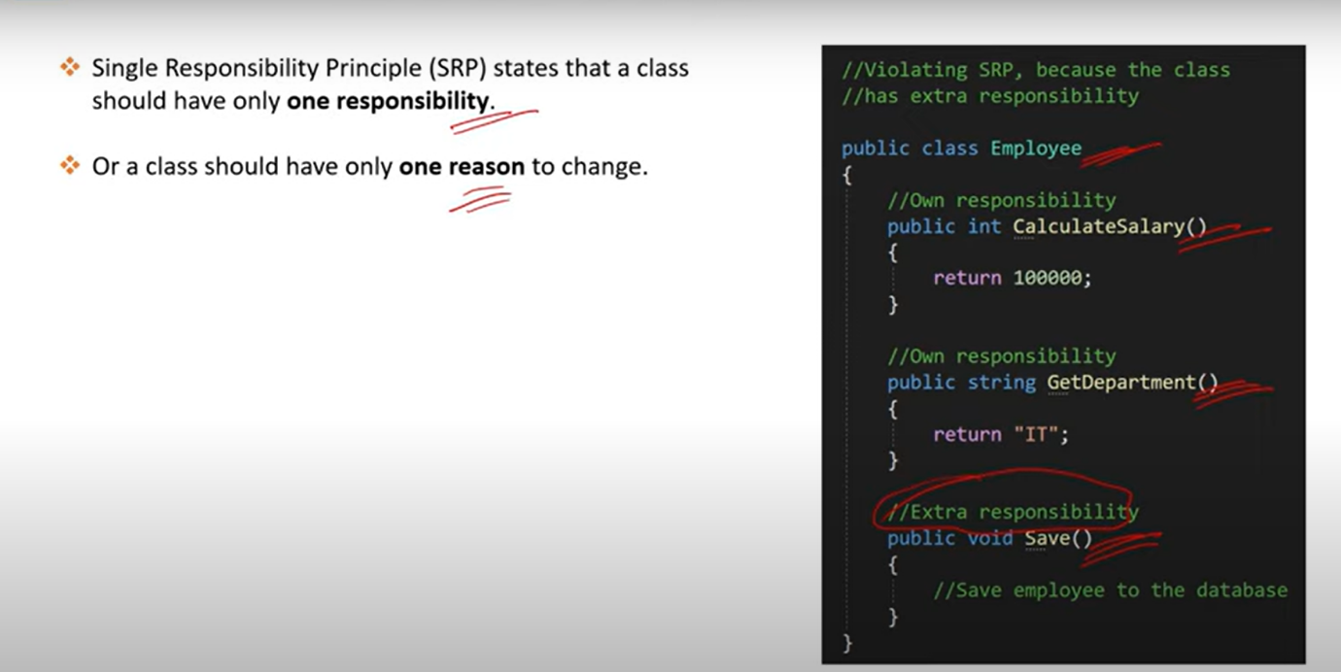

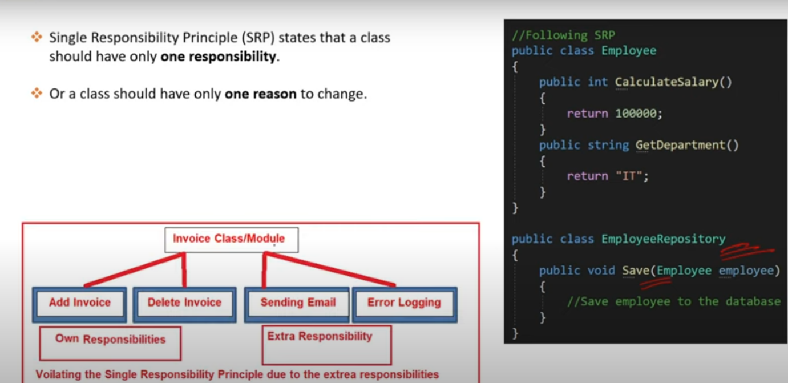

1. OCP – Open Close Principle

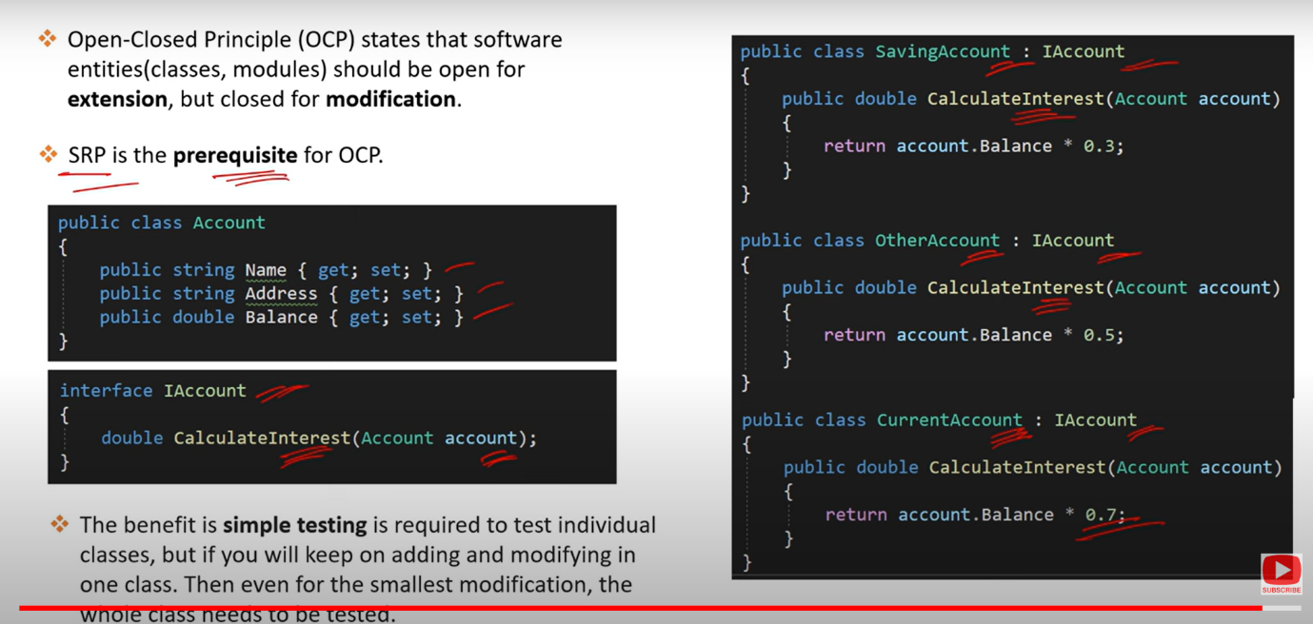

1. LSP – Liskov Substitution Principle

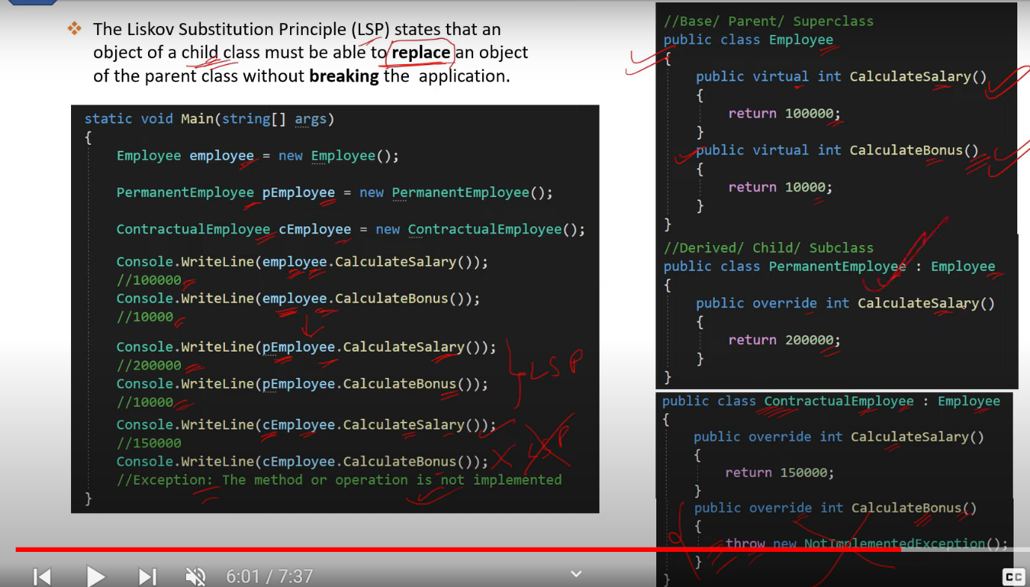

1. ISP – Interface Segregation Principle

1. DIP – Dependency Inversion Principle

